Caser ciper
def encrypt_caesar(text, shift):
result = ""
for char in text:
if char.isalpha():
base = ord('A') if char.isupper() else ord('a')
new_char = ord(char) + shift

# Wrap around alphabet
if char.islower():
if new_char > ord('z'):
new_char -= 26
elif new_char < ord('a'):
new_char += 26
else: # uppercase
if new_char > ord('Z'):
new_char -= 26
elif new_char < ord('A'):
new_char += 26

result += chr(new_char)
else:
result += char
return result

# --- Main program ---
text = input("Enter message (or cipher text): ")
shift = int(input("Enter shift key: "))
choice = input("Do you want to encrypt or decrypt the message? (Enter 'encrypt' or 'decrypt'): ").lower()

if choice == 'encrypt':
encrypted = encrypt_caesar(text, shift)
print("Encrypted message:", encrypted)
elif choice == 'decrypt':
decrypted = encrypt_caesar(text, -shift)
print("Decrypted message:", decrypted)
else:
print("Invalid choice! Please enter 'encrypt' or 'decrypt'.")

OUTPUT:
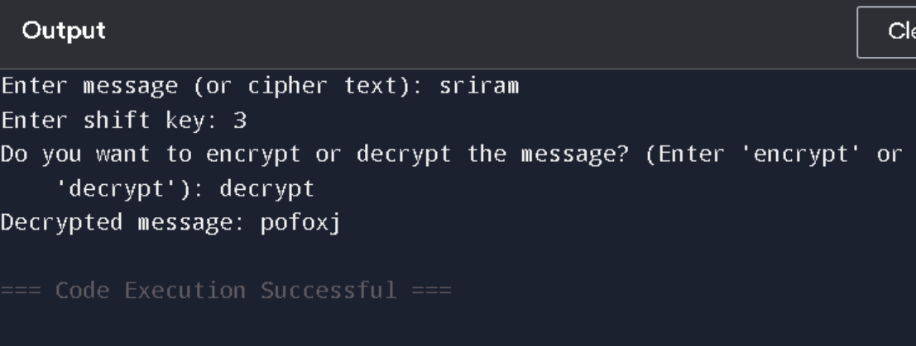

mono alphabetic
def encrypt(text, key):
result = ""
for char in text:
if char.isalpha():
index = ord(char.lower()) - ord('a')
new_char = key[index]
result += new_char.upper() if char.isupper() else new_char
else:
result += char
return result
def decrypt(text, key):
result = ""
for char in text:
if char.isalpha():
index = key.index(char.lower())
new_char = chr(index + ord('a'))
result += new_char.upper() if char.isupper() else new_char
else: result += char
return result
key = "phqgiumeaylnofdxjkrcvstzwb"
text = input("Enter the text: ")
choice = input("Encrypt or Decrypt? ").lower()
if choice == "encrypt":
print("Encrypted:", encrypt(text, key))
elif choice == "decrypt":
print("Decrypted:", decrypt(text, key))
else:
print("Invalid choice")

OUTPUT:
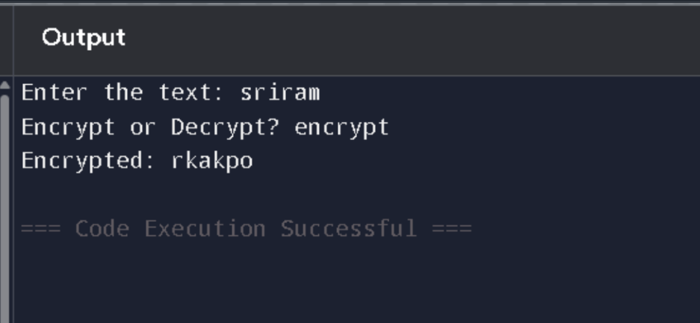

🔐 Polyalphabetic

def generate_key(text, keyword):
key = keyword
while len(key) < len(text):
key += keyword
return key[:len(text)]

def encrypt(text, keyword):
key = generate_key(text, keyword)
cipher_text = ""
for i in range(len(text)):
if text[i].isalpha():
shift = ord(key[i].lower()) - ord('a')
if text[i].isupper():
cipher_text += chr((ord(text[i]) - 65 + shift) % 26 + 65)
else:
cipher_text += chr((ord(text[i]) - 97 + shift) % 26 + 97)
else:
cipher_text += text[i]
return cipher_text

def decrypt(ciphertext, keyword):
key = generate_key(ciphertext, keyword)
orig_text = ""
for i in range(len(ciphertext)):
if ciphertext[i].isalpha():
shift = ord(key[i].lower()) - ord('a')
if ciphertext[i].isupper():
orig_text += chr((ord(ciphertext[i]) - 65 - shift + 26) % 26 + 65)
else:
orig_text += chr((ord(ciphertext[i]) - 97 - shift + 26) % 26 + 97)
else:
orig_text += ciphertext[i]
return orig_text

# --- Main Program ---
plaintext = input("Enter the plaintext: ")
keyword = input("Enter the keyword: ")

encrypted = encrypt(plaintext, keyword)
decrypted = decrypt(encrypted, keyword)

print("\nEncrypted Text:", encrypted)
print("Decrypted Text:", decrypted)

OUT PUT:
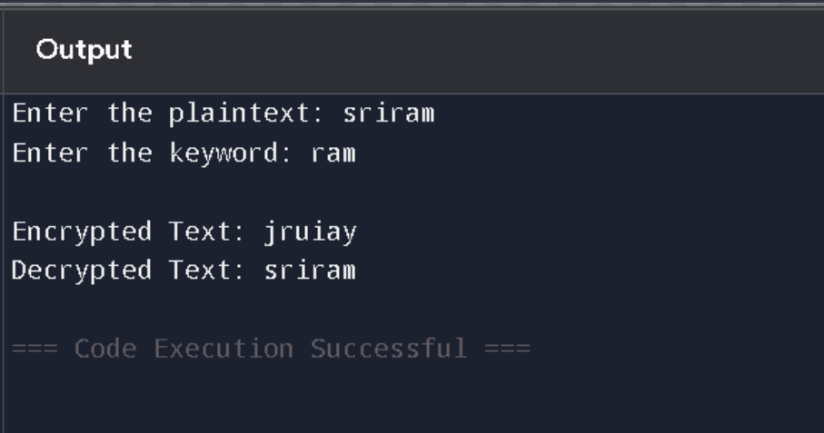

🔐 Rail Fence Cipher

def encrypt(plaintext, rails):
# Create a list to hold the encrypted text for each rail
rail = [['' for _ in range(len(plaintext))] for _ in range(rails)]

# Find the position to write each character in the rail matrix
direction = 1 # 1 means down, -1 means up
row, col = 0, 0

for char in plaintext:
rail[row][col] = char
col += 1
row += direction

if row == rails: # Change direction when reaching bottom rail
row = rails - 2
direction = -1
elif row == -1: # Change direction when reaching top rail
row = 1
direction = 1

# Read the matrix row by row to form the ciphertext
cipher_text = ''.join([''.join(rail[i]) for i in range(rails)])
return cipher_text

def decrypt(ciphertext, rails):
# Create a list to hold the decrypted text for each rail
rail = [['' for _ in range(len(ciphertext))] for _ in range(rails)]

# Mark the position of each character in the matrix
direction = 1
row, col = 0, 0
for i in range(len(ciphertext)):
rail[row][col] = '*'
col += 1
row += direction

if row == rails:
row = rails - 2
direction = -1
elif row == -1:
row = 1
direction = 1

# Fill the matrix with the ciphertext
index = 0
for i in range(rails):
for j in range(len(ciphertext)):
if rail[i][j] == '*':
rail[i][j] = ciphertext[index]
index += 1

# Read the matrix column by column to get the plaintext
result = []
row, col = 0, 0
for i in range(len(ciphertext)):
result.append(rail[row][col])
col += 1
row += direction

if row == rails:
row = rails - 2
direction = -1
elif row == -1:
row = 1
direction = 1

return ''.join(result)

# --- Main Program ---
plaintext = input("Enter the plaintext: ")
rails = int(input("Enter the number of rails: "))

encrypted = encrypt(plaintext, rails)
decrypted = decrypt(encrypted, rails)

print("\nEncrypted Text:", encrypted)
print("Decrypted Text:", decrypted)

OUT PUT:
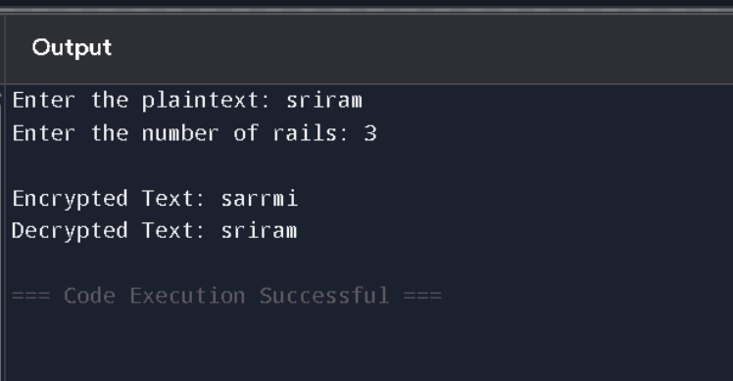

🔐 Playfair Cipher

def create_matrix(key):
# Remove duplicate letters and 'J' is combined with 'I'
key = key.upper().replace("J", "I")
seen = set()
matrix = []
for char in key:
if char not in seen and char.isalpha():
seen.add(char)
matrix.append(char)

# Add remaining letters of the alphabet to fill the matrix
alphabet = "ABCDEFGHIKLMNOPQRSTUVWXYZ"
for char in alphabet:
if char not in seen:
matrix.append(char)

# Return the 5x5 matrix
return [matrix[i:i+5] for i in range(0, 25, 5)]

def prepare_text(text):
# Remove non-alphabetical characters and convert to uppercase
text = text.upper().replace("J", "I")
prepared_text = []

i = 0
while i < len(text):
if i + 1 < len(text) and text[i] == text[i + 1]:
prepared_text.append(text[i] + 'X')
i += 1
else:
if i + 1 < len(text):
prepared_text.append(text[i] + text[i + 1])
i += 2
else:
prepared_text.append(text[i] + 'X')
i += 1

return prepared_text

def find_position(char, matrix):
for i in range(5):
for j in range(5):
if matrix[i][j] == char:
return i, j

def encrypt_digraph(digraph, matrix):
row1, col1 = find_position(digraph[0], matrix)
row2, col2 = find_position(digraph[1], matrix)

if row1 == row2:
# Same row: move right
col1 = (col1 + 1) % 5
col2 = (col2 + 1) % 5
elif col1 == col2:
# Same column: move down
row1 = (row1 + 1) % 5
row2 = (row2 + 1) % 5
else:
# Rectangle: swap columns
col1, col2 = col2, col1

return matrix[row1][col1] + matrix[row2][col2]

def decrypt_digraph(digraph, matrix):
row1, col1 = find_position(digraph[0], matrix)
row2, col2 = find_position(digraph[1], matrix)

if row1 == row2:
# Same row: move left
col1 = (col1 - 1) % 5
col2 = (col2 - 1) % 5
elif col1 == col2:
# Same column: move up
row1 = (row1 - 1) % 5
row2 = (row2 - 1) % 5
else:
# Rectangle: swap columns
col1, col2 = col2, col1

return matrix[row1][col1] + matrix[row2][col2]

def encrypt(text, key):
matrix = create_matrix(key)
prepared_text = prepare_text(text)
encrypted_text = ''.join([encrypt_digraph(digraph, matrix) for digraph in prepared_text])
return encrypted_text

def decrypt(text, key):
matrix = create_matrix(key)
digraphs = [text[i:i+2] for i in range(0, len(text), 2)]
decrypted_text = ''.join([decrypt_digraph(digraph, matrix) for digraph in digraphs])
return decrypted_text

# --- Main Program ---
plaintext = input("Enter the plaintext: ")
key = input("Enter the key: ")

encrypted = encrypt(plaintext, key)
decrypted = decrypt(encrypted, key)

print("\nEncrypted Text:", encrypted)
print("Decrypted Text:", decrypted)

Hill Cipher

import numpy as np

def create_matrix(key):
# Create a 2x2 matrix from the key (4 characters)
return np.array([[ord(key[0])-65, ord(key[1])-65], [ord(key[2])-65, ord(key[3])-65]])

def text_to_numbers(text):
# Convert text to numbers (A=0, B=1, ..., Z=25)
numbers = []
for char in text.upper():
if char.isalpha():
numbers.append(ord(char) - 65)
return numbers

def numbers_to_text(numbers):
# Convert numbers back to text
text = ""
for num in numbers:
text += chr(num + 65)
return text

def encrypt(plaintext, key):
# Ensure the plaintext length is a multiple of 2 (pad if needed)
if len(plaintext) % 2 != 0:
plaintext += 'X'

# Convert plaintext to numbers
text_numbers = text_to_numbers(plaintext)

# Create the key matrix
key_matrix = create_matrix(key)

ciphertext_numbers = []

# Encrypt in blocks of 2
for i in range(0, len(text_numbers), 2):
block = np.array(text_numbers[i:i+2]).reshape(2, 1)
encrypted_block = np.dot(key_matrix, block) % 26
ciphertext_numbers.extend(encrypted_block.flatten())

return numbers_to_text(ciphertext_numbers)

def decrypt(ciphertext, key):
# Convert ciphertext to numbers
cipher_numbers = text_to_numbers(ciphertext)

# Create the key matrix
key_matrix = create_matrix(key)

# Find the inverse of the key matrix modulo 26
det = int(np.linalg.det(key_matrix)) % 26
det_inv = pow(det, -1, 26)

# Find the inverse matrix
key_matrix_inv = det_inv * np.round(np.linalg.inv(key_matrix) * det) % 26
key_matrix_inv = key_matrix_inv.astype(int)

plaintext_numbers = []

# Decrypt in blocks of 2
for i in range(0, len(cipher_numbers), 2):
block = np.array(cipher_numbers[i:i+2]).reshape(2, 1)
decrypted_block = np.dot(key_matrix_inv, block) % 26
plaintext_numbers.extend(decrypted_block.flatten())

return numbers_to_text(plaintext_numbers)

# --- Main Program ---
plaintext = input("Enter the plaintext: ")
key = input("Enter the 4-character key (e.g., 'GYBNQKUS'): ")

encrypted = encrypt(plaintext, key)
decrypted = decrypt(encrypted, key)

print("\nEncrypted Text:", encrypted)
print("Decrypted Text:", decrypted)

OUTPUT:
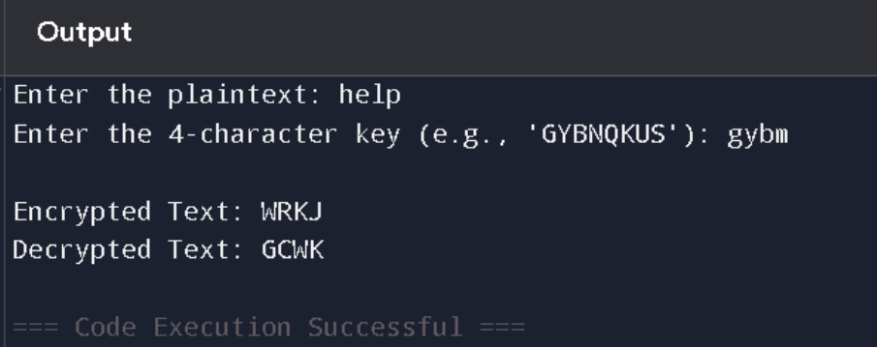

Columnar ciper

def columnar_encrypt(plaintext, key):
# Remove spaces and make the plaintext uppercase
plaintext = plaintext.replace(" ", "").upper()

# Find the number of columns based on the key length
num_columns = len(key)
num_rows = len(plaintext) // num_columns
if len(plaintext) % num_columns != 0:
num_rows += 1

# Create a matrix and fill with the plaintext
matrix = ['' for _ in range(num_rows)]
index = 0
for i in range(num_rows):
for j in range(num_columns):
if index < len(plaintext):
matrix[i] += plaintext[index]
index += 1

# Read the matrix column by column, in order of the key
ciphertext = ""
for i in sorted(range(len(key)), key=lambda x: key[x]):
for j in range(num_rows):
if i < len(matrix[j]):
ciphertext += matrix[j][i]

return ciphertext

def columnar_decrypt(ciphertext, key):
# Calculate number of rows and columns
num_columns = len(key)
num_rows = len(ciphertext) // num_columns
if len(ciphertext) % num_columns != 0:
num_rows += 1

# Create the matrix and fill it column by column based on the key
matrix = ['' for _ in range(num_rows)]
index = 0
for i in sorted(range(len(key)), key=lambda x: key[x]):
for j in range(num_rows):
if index < len(ciphertext):
matrix[j] += ciphertext[index]
index += 1

# Read the matrix row by row
plaintext = ""
for i in range(num_rows):
plaintext += matrix[i]

return plaintext

# --- Main Program ---
plaintext = input("Enter the plaintext: ")
key = input("Enter the key (e.g., 'HILL'): ")

# Encryption
encrypted = columnar_encrypt(plaintext, key)
# Decryption
decrypted = columnar_decrypt(encrypted, key)

print("\nEncrypted Text:", encrypted)
print("Decrypted Text:", decrypted)

OUTPUT: 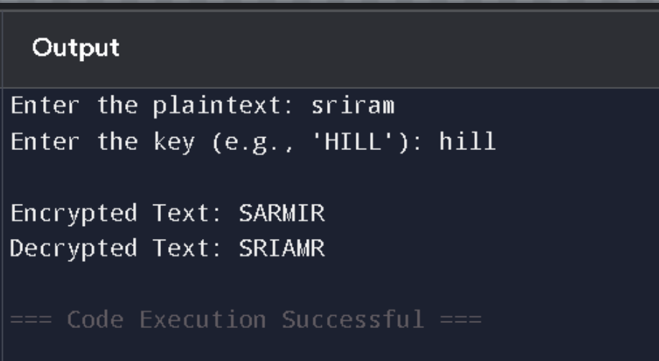

AFFINE CIPER

def gcd(a, b):
while b:
a, b = b, a % b
return a

def mod_inverse(a, m):
for i in range(1, m):
if (a * i) % m == 1:
return i
return None

def affine_encrypt(text, a, b):
if gcd(a, 26) != 1:
raise ValueError("a must be coprime with 26")
result = ''
for char in text:
if char.isalpha():
offset = ord('A') if char.isupper() else ord('a')
x = ord(char) - offset
encrypted = (a * x + b) % 26
result += chr(encrypted + offset)
else:
result += char
return result

def affine_decrypt(cipher, a, b):
a_inv = mod_inverse(a, 26)
if a_inv is None:
raise ValueError("Modular inverse of a doesn't exist")
result = ''
for char in cipher:
if char.isalpha():
offset = ord('A') if char.isupper() else ord('a')
y = ord(char) - offset
decrypted = (a_inv * (y - b)) % 26
result += chr(decrypted + offset)
else:
result += char
return result

# --- User Input ---
mode = input("Enter mode (encrypt/decrypt): ").strip().lower()
text = input("Enter text: ")
a = int(input("Enter key 'a' (must be coprime with 26): "))
b = int(input("Enter key 'b': "))

if mode == "encrypt":
encrypted = affine_encrypt(text, a, b)
print("Encrypted text:", encrypted)
elif mode == "decrypt":
decrypted = affine_decrypt(text, a, b)
print("Decrypted text:", decrypted)
else:
print("Invalid mode. Please enter 'encrypt' or 'decrypt'.")

OUTPUT:
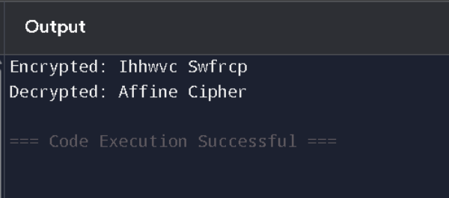

Diffie-Hellman

class Point:
def __init__(self, x, y, curve):
self.x = x
self.y = y
self.curve = curve

def __eq__(self, other):
return isinstance(other, Point) and self.x == other.x and self.y == other.y

def __str__(self):
return f"({self.x}, {self.y})"

class EllipticCurve:
def __init__(self, a, b, p):
self.a = a
self.b = b
self.p = p
if (4 * a**3 + 27 * b**2) % p == 0:
raise ValueError("Invalid curve: singular (a and b result in a singular curve).")

def is_on_curve(self, point):
if point is None:
return True
x, y = point.x, point.y
return (y**2 - (x**3 + self.a * x + self.b)) % self.p == 0

def inverse_mod(self, k):
try:
return pow(k, -1, self.p)
except ValueError:
raise ValueError(f"No modular inverse for {k} mod {self.p}. Make sure denominator is not zero.")

def point_add(self, P, Q):
if P is None: return Q
if Q is None: return P
if P.x == Q.x and (P.y != Q.y or P.y == 0):
return None # Point at infinity

if P != Q:
denom = Q.x - P.x
if denom % self.p == 0:
raise ValueError("Invalid addition: division by zero")
m = ((Q.y - P.y) * self.inverse_mod(denom)) % self.p
else:
denom = 2 * P.y
if denom % self.p == 0:
raise ValueError("Invalid doubling: division by zero")
m = ((3 * P.x**2 + self.a) * self.inverse_mod(denom)) % self.p

x_r = (m**2 - P.x - Q.x) % self.p
y_r = (m * (P.x - x_r) - P.y) % self.p
return Point(x_r, y_r, self)

def scalar_mult(self, k, P):
result = None
addend = P
while k:
if k & 1:
result = self.point_add(result, addend)
addend = self.point_add(addend, addend)
k >>= 1
return result

# === USER INPUT ===
try:
print("Enter elliptic curve parameters:")
a = int(input(" Curve coefficient a: "))
b = int(input(" Curve coefficient b: "))
p = int(input(" Prime modulus p: "))

curve = EllipticCurve(a, b, p)

print("\nEnter base point G:")
x = int(input(" x-coordinate: "))
y = int(input(" y-coordinate: "))
G = Point(x, y, curve)

if not curve.is_on_curve(G):
raise ValueError("The base point G is not on the elliptic curve.")

a_priv = int(input("\nEnter Alice's private key: "))
b_priv = int(input("Enter Bob's private key: "))

# Compute public keys
A_pub = curve.scalar_mult(a_priv, G)
B_pub = curve.scalar_mult(b_priv, G)

# Compute shared secrets
shared_a = curve.scalar_mult(a_priv, B_pub)
shared_b = curve.scalar_mult(b_priv, A_pub)

print("\n=== RESULTS ===")
print(f"Alice's public key: {A_pub}")
print(f"Bob's public key: {B_pub}")
print(f"Alice's shared secret: {shared_a}")
print(f"Bob's shared secret: {shared_b}")

if shared_a == shared_b:
print("✅ Shared secrets match! ECDH successful.")
else:
print("❌ Shared secrets do not match.")

except ValueError as e:
print(f"\n❌ ERROR: {e}")

OUTPUT:
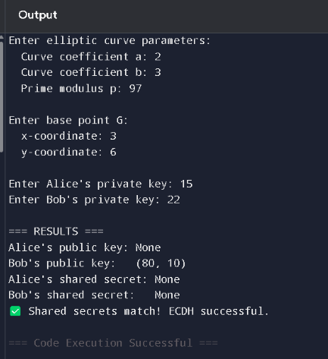

🔐 Elliptic Curve

class Point:
def __init__(self, x, y, curve):
self.x = x
self.y = y
self.curve = curve

def __eq__(self, other):
return isinstance(other, Point) and self.x == other.x and self.y == other.y

def __str__(self):
return f"({self.x}, {self.y})"

class EllipticCurve:
def __init__(self, a, b, p):
self.a = a
self.b = b
self.p = p
if (4 * a**3 + 27 * b**2) % p == 0:
raise ValueError("Invalid curve: singular (a and b result in a singular curve).")

def is_on_curve(self, point):
if point is None:
return True
x, y = point.x, point.y
return (y**2 - (x**3 + self.a * x + self.b)) % self.p == 0

def inverse_mod(self, k):
try:
return pow(k, -1, self.p)
except ValueError:
raise ValueError(f"No modular inverse for {k} mod {self.p}. Make sure denominator is not zero.")

def point_add(self, P, Q):
if P is None: return Q
if Q is None: return P
if P.x == Q.x and (P.y != Q.y or P.y == 0):
return None # Point at infinity

if P != Q:
denom = Q.x - P.x
if denom % self.p == 0:
raise ValueError("Invalid addition: division by zero")
m = ((Q.y - P.y) * self.inverse_mod(denom)) % self.p
else:
denom = 2 * P.y
if denom % self.p == 0:
raise ValueError("Invalid doubling: division by zero")
m = ((3 * P.x**2 + self.a) * self.inverse_mod(denom)) % self.p

x_r = (m**2 - P.x - Q.x) % self.p
y_r = (m * (P.x - x_r) - P.y) % self.p
return Point(x_r, y_r, self)

def scalar_mult(self, k, P):
result = None
addend = P
while k:
if k & 1:
result = self.point_add(result, addend)
addend = self.point_add(addend, addend)
k >>= 1
return result

# === USER INPUT ===
try:
print("Enter elliptic curve parameters:")
a = int(input(" Curve coefficient a: "))
b = int(input(" Curve coefficient b: "))
p = int(input(" Prime modulus p: "))

curve = EllipticCurve(a, b, p)

print("\nEnter base point G:")
x = int(input(" x-coordinate: "))
y = int(input(" y-coordinate: "))
G = Point(x, y, curve)

if not curve.is_on_curve(G):
raise ValueError("The base point G is not on the elliptic curve.")

a_priv = int(input("\nEnter Alice's private key: "))
b_priv = int(input("Enter Bob's private key: "))

# Compute public keys
A_pub = curve.scalar_mult(a_priv, G)
B_pub = curve.scalar_mult(b_priv, G)

# Compute shared secrets
shared_a = curve.scalar_mult(a_priv, B_pub)
shared_b = curve.scalar_mult(b_priv, A_pub)

print("\n=== RESULTS ===")
print(f"Alice's public key: {A_pub}")
print(f"Bob's public key: {B_pub}")
print(f"Alice's shared secret: {shared_a}")
print(f"Bob's shared secret: {shared_b}")

if shared_a == shared_b:
print("✅ Shared secrets match! ECDH successful.")
else:
print("❌ Shared secrets do not match.")

except ValueError as e:
print(f"\n❌ ERROR: {e}")

OUTPUT:
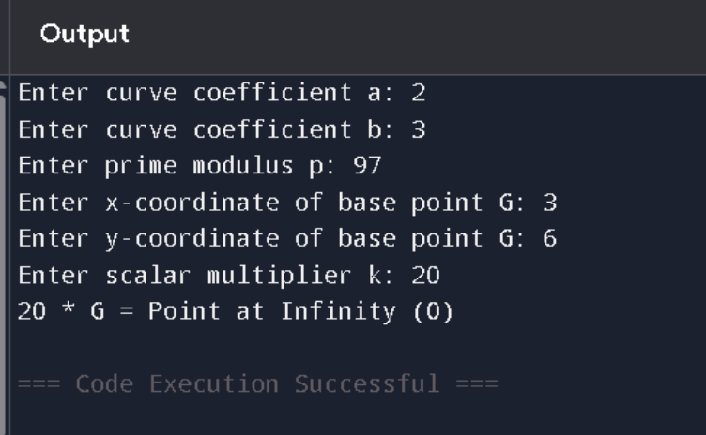

🐍 Triple DES in Python

# Reusing the DES code from previous example
IP = [
58,50,42,34,26,18,10,2,
60,52,44,36,28,20,12,4,
62,54,46,38,30,22,14,6,
64,56,48,40,32,24,16,8,
57,49,41,33,25,17,9,1,
59,51,43,35,27,19,11,3,
61,53,45,37,29,21,13,5,
63,55,47,39,31,23,15,7
]

FP = [
40,8,48,16,56,24,64,32,
39,7,47,15,55,23,63,31,
38,6,46,14,54,22,62,30,
37,5,45,13,53,21,61,29,
36,4,44,12,52,20,60,28,
35,3,43,11,51,19,59,27,
34,2,42,10,50,18,58,26,
33,1,41,9,49,17,57,25
]

def permute(block, table):
output = 0
for position in table:
output <<= 1
output |= (block >> (64 - position)) & 1
return output

def feistel(right, key):
return right ^ (key & 0xFFFFFFFF)

def des_round(left, right, key):
new_right = left ^ feistel(right, key)
return right, new_right

def des_encrypt_decrypt(block, key, decrypt=False):
block = permute(block, IP)
left = (block >> 32) & 0xFFFFFFFF
right = block & 0xFFFFFFFF
for i in range(16):
left, right = des_round(left, right, key)
combined = (right << 32) | left
return permute(combined, FP)

# TRIPLE DES function using EDE: Encrypt-Decrypt-Encrypt
def triple_des(block, key1, key2, key3, decrypt=False):
if decrypt:
# Decrypt-Encrypt-Decrypt
step1 = des_encrypt_decrypt(block, key3, decrypt=True)
step2 = des_encrypt_decrypt(step1, key2, decrypt=False)
step3 = des_encrypt_decrypt(step2, key1, decrypt=True)
else:
# Encrypt-Decrypt-Encrypt
step1 = des_encrypt_decrypt(block, key1, decrypt=False)
step2 = des_encrypt_decrypt(step1, key2, decrypt=True)
step3 = des_encrypt_decrypt(step2, key3, decrypt=False)
return step3

# MAIN
def main():
print("=== Triple DES (3DES) Encryption/Decryption ===")
choice = input("Choose (1: Encrypt, 2: Decrypt): ")

msg_hex = input("Enter 16-digit hex message: ")
k1_hex = input("Enter 16-digit hex Key 1 : ")
k2_hex = input("Enter 16-digit hex Key 2 : ")
k3_hex = input("Enter 16-digit hex Key 3 : ")

message = int(msg_hex, 16)
key1 = int(k1_hex, 16)
key2 = int(k2_hex, 16)
key3 = int(k3_hex, 16)

result = triple_des(message, key1, key2, key3, decrypt=(choice == "2"))
print(f"\nResult: {result:016X}")

if __name__ == "__main__":
main()

OUTPUT:
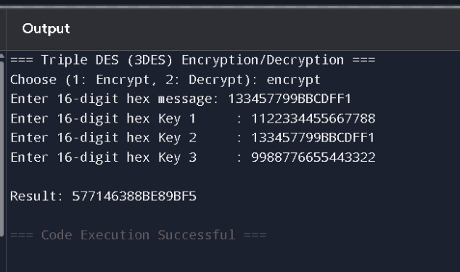

🐍 Simple DES Algorithm in Python

# Simplified DES algorithm in Python

# Initial and Final Permutation Tables (64-bit)
IP = [
58,50,42,34,26,18,10,2,
60,52,44,36,28,20,12,4,
62,54,46,38,30,22,14,6,
64,56,48,40,32,24,16,8,
57,49,41,33,25,17,9,1,
59,51,43,35,27,19,11,3,
61,53,45,37,29,21,13,5,
63,55,47,39,31,23,15,7
]

FP = [
40,8,48,16,56,24,64,32,
39,7,47,15,55,23,63,31,
38,6,46,14,54,22,62,30,
37,5,45,13,53,21,61,29,
36,4,44,12,52,20,60,28,
35,3,43,11,51,19,59,27,
34,2,42,10,50,18,58,26,
33,1,41,9,49,17,57,25
]

# Permutation function
def permute(block, table):
output = 0
for position in table:
output <<= 1
output |= (block >> (64 - position)) & 1
return output

# Simple Feistel function using XOR
def feistel(right, key):
return right ^ (key & 0xFFFFFFFF)

# One DES round
def des_round(left, right, key):
new_right = left ^ feistel(right, key)
return right, new_right

# Simplified DES process
def des_encrypt_decrypt(block, key, decrypt=False):
# Initial permutation
block = permute(block, IP)

# Split into left and right 32 bits
left = (block >> 32) & 0xFFFFFFFF
right = block & 0xFFFFFFFF

# 16 rounds
for i in range(16):
left, right = des_round(left, right, key)

# Combine and apply final permutation
combined = (right << 32) | left
return permute(combined, FP)

# Main interaction
def main():
print("=== Simple DES Encryption/Decryption ===")
choice = input("Choose (1: Encrypt, 2: Decrypt): ")

msg_hex = input("Enter 16-digit hex message (e.g. 0123456789ABCDEF): ")
key_hex = input("Enter 16-digit hex key (e.g. 133457799BBCDFF1): ")

message = int(msg_hex, 16)
key = int(key_hex, 16)

result = des_encrypt_decrypt(message, key, decrypt=(choice == "2"))
print(f"\nResult: {result:016X}")

if __name__ == "__main__":
main()

OUTPUT: 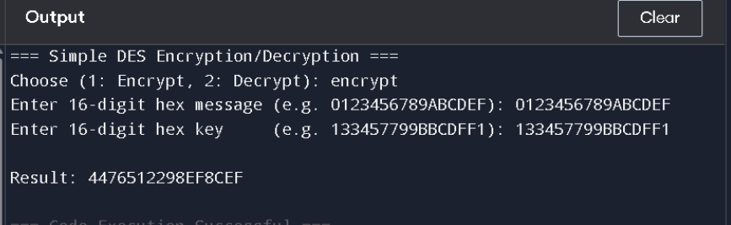

BLOW Fish Algorithm

# Simulated Blowfish-like encryption (educational only)

def simple_f(x):
return ((x * 2654435761) & 0xFFFFFFFF) >> 1 # Mock F-function

def encrypt_block(l, r, p):
for i in range(16):
l ^= p[i]
r ^= simple_f(l)
l, r = r, l
l, r = r, l
r ^= p[16]
l ^= p[17]
return l, r

def decrypt_block(l, r, p):
for i in range(17, 1, -1):
l ^= p[i]
r ^= simple_f(l)
l, r = r, l
l, r = r, l
r ^= p[1]
l ^= p[0]
return l, r

def str_to_ints(text):
bytes_data = text.encode().ljust(8, b'\x00')
return int.from_bytes(bytes_data[:4], 'big'), int.from_bytes(bytes_data[4:8], 'big')

def ints_to_str(l, r):
return (l.to_bytes(4, 'big') + r.to_bytes(4, 'big')).rstrip(b'\x00').decode()

# Sample P-array (simple XOR pattern for demonstration)
P = [i ^ 0x243F6A88 for i in range(18)]

# === User input ===
plaintext = input("Enter a message (max 8 characters): ").strip()

# Ensure it's no more than 8 characters
if len(plaintext) > 8:
print("Input too long! Please enter 8 characters or fewer.")
else:
# Encrypt
l, r = str_to_ints(plaintext)
l_enc, r_enc = encrypt_block(l, r, P)
print("\nEncrypted integers:", l_enc, r_enc)

# Decrypt
l_dec, r_dec = decrypt_block(l_enc, r_enc, P)
decrypted = ints_to_str(l_dec, r_dec)
print("Decrypted message:", decrypted)

output:
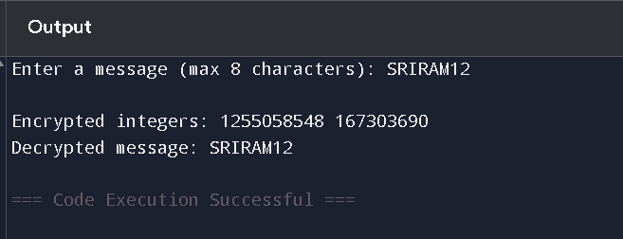

RSA Algorithm

# Python Program for implementation of RSA Algorithm

def power(base, expo, m):
res = 1
base = base % m
while expo > 0:
if expo & 1:
res = (res * base) % m
base = (base * base) % m
expo = expo // 2
return res

# Function to find modular inverse of e modulo phi(n)
def modInverse(e, phi):
for d in range(2, phi):
if (e * d) % phi == 1:
return d
return -1

# RSA Key Generation
def generateKeys(p, q):
n = p * q
phi = (p - 1) * (q - 1)

# Choose e, where 1 < e < phi(n) and gcd(e, phi(n)) == 1
e = 0
for e in range(2, phi):
if gcd(e, phi) == 1:
break

# Compute d such that e * d ≡ 1 (mod phi(n))
d = modInverse(e, phi)

return e, d, n

# Function to calculate gcd
def gcd(a, b):
while b != 0:
a, b = b, a % b
return a

# Encrypt message using public key (e, n)
def encrypt(m, e, n):
return power(m, e, n)

# Decrypt message using private key (d, n)
def decrypt(c, d, n):
return power(c, d, n)

# Main execution
if __name__ == "__main__":

# Input primes p and q
p = int(input("Enter prime number p: "))
q = int(input("Enter prime number q: "))

# Key Generation
e, d, n = generateKeys(p, q)

print(f"Public Key (e, n): ({e}, {n})")
print(f"Private Key (d, n): ({d}, {n})")

# Input message
M = int(input("Enter the message to encrypt (as an integer): "))
print(f"Original Message: {M}")

# Encrypt the message
C = encrypt(M, e, n)
print(f"Encrypted Message: {C}")

# Decrypt the message
decrypted = decrypt(C, d, n)
print(f"Decrypted Message: {decrypted}")

output:
